And He Shall Rule Over Her
About the Author
Bio (58 words)
Sophie Kisker was astonished to find out that others shared the D/s fantasies that she’d been writing about for years. Now out of the closet, she splits her time between being mother, wife, and overworked employee, and hiding in her office cave to write, where she only cares about her internet signal and the strength of her coffee.

Social Media
Newsletter - https://landing.mailerlite.com/webforms/landing/y1v0n2

Facebook – www.facebook.com/sophie.kisker.9

Blog - www.sophiekisker.com

Email - sophiekisker@gmail.com

Media Kit
Buy Link: https://www.amazon.com/dp/B077SDX5Q6/
Author: Sophie Kisker
Word Count: 5,100/ 22 pages
Published: 11/27/17

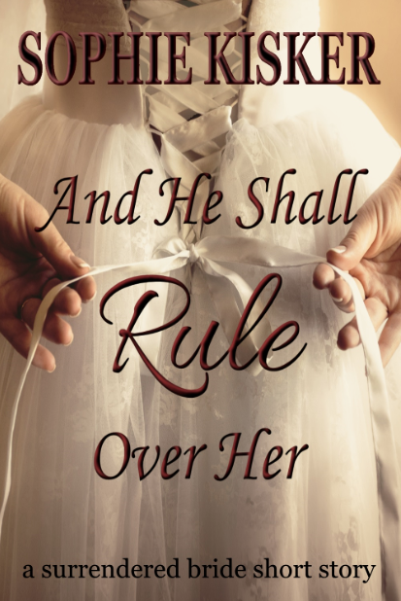
Short Synopsis (112 words)
You're invited to the wedding of Becca and Ian. But it's not an ordinary wedding, because Becca must completely surrender to the man who loves her. You will witness as she kneels to accept his collar. You will watch her submit as he does something unexpected that she must bear in silence. And at the reception, you'll feel her struggle to accept her new life as she places herself on the spanking bench for the ritual of the First Chastisement. And through it all, you'll see the deep love they share for each other.

This is a 5,000-word story of unequal power exchange and freely given surrender, with scenes of physical discipline.

Long Synopsis (196 words)

This is a story of surrender and discipline. It's not a sweet and pure romance.
Becca Albright is marrying the man of her dreams today. He's handsome and funny, and he loves her deeply. But accepting his proposal may be the last significant choice she gets to make, because after the ceremony, she will legally belong to him for the rest of her life. She must surrender herself completely to his will, and he will correct her as he sees fit, and they will live happily ever after.

But first, they have a wedding.

You're invited to the ceremony, to witness as she kneels to accept his collar. You will watch her submit as he does something unexpected that she must bear in silence. And at the reception, you'll feel her struggle to accept her new life as she places herself on the spanking bench for the ritual of the First Chastisement. And through it all, you'll see them affirm their deep love for each other.
Is this the kind of wedding you secretly long for?

This short, 5,000-word story has power exchange and freely given surrender, and scenes of physical discipline.

Tagline, teasers, tweets

Quotes from Amazon Reviews
“Once again, Ms. Kisker delivers just the right amount of love, passion, pain, dominance and submission.”
“It's an enthralling mixture of the unusual and the conventional, light and dark, joy and trepidation, and the all-consuming power of love. To give this book anything less than five stars is unthinkable!”

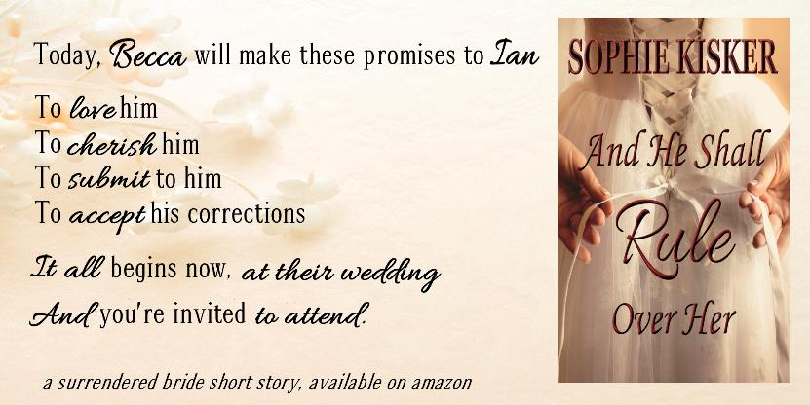

Excerpts

